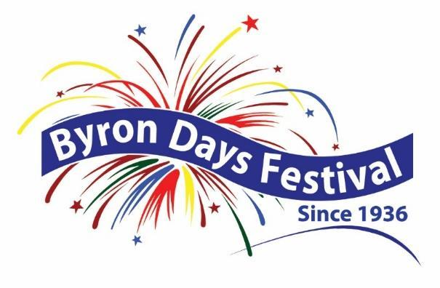

SpartanNash Byron Days

PARADE
REGISTRATION
Saturday, July 25, 2026

Parade Line-up Starts at 9:00am ~ 9:45am: Enter in the ONE-WAY ENTRANCE of BC Waddell Field BCPS Central Sports Complex off 84th Street SW, and head to the bus garage area for the line-up. Parade line-up is determined by arrival time and conducted by the Parade Marshals.

Semi-Trucks: Park in the surrounding side streets south of Heritage Elementary School, 8638 Byron Center Ave. This is the dedicated parade exit heading north. Drivers should then check-in with the Parade Marshals.

Starting Time: The parade starts at 10:00am SHARP, and will leave from the Heritage Elementary School parking lot by the bus garages.

Parade Route: The parade will travel north on Byron Center Ave to 84th Street; West on 84th Street to Merton; North on Merton to Sherwood; East on Sherwood to Byron Center Ave; North on Byron Center Ave ending at Rush Creek Church.

Handouts: Candy and other items can be passed out along the parade route; handouts cannot be thrown from a vehicle or float by children. You are welcome to hand out candy, etc; however, IT MUST REACH THE CURB FOR THE SAFETY OF CHILDREN! Spraying water by any means is prohibited.
Return this completed Registration Form and check to:
Byron Days Festival Parade, P.O. Box 185, Byron Center MI 49315

ENTRY FEE: $10 per vehicle or walking group unit (no more than 4 units) Number of Units: ________

APPLICATION INFORMATION:

PRIMARY CONTACT NAME: DATE:

NAME OF BUSINESS/ORGANIZATION:

ADDRESS: CITY: ZIP:

PRIMARY PHONE: EMAIL (FOR REGISTRATION CONFIRMATION):

BRIEFLY DESCRIBE YOUR ENTRY: ________________________________________________________________________________________
________________________________________________________________________________________
________________________________________________________________________________________
________________________________________________________________________________________

ANIMALS: YES: ______ NO: ______

DOGS: ______ HORSES: ______ OTHER (PLEASE IDENTIFY): _________________________

ENTRANTS MUST CLEAN UP AFTER ANIMALS IMMEDIATELY ALONG THE PARADE ROUTE

MOTORIZED VEHICLE:  YES: ______ NO: ______ | DRIVERS NAME:
DRIVER’S LICENSE NUMBER | PROOF OF INSURANCE EXPIRATION DATE:
SPOTTERS: (MUST BE 18 YEARS OLD OR OLDER)
Large floats and/or trucks over 60 feet must provide four (4) spotters. Two on each side of the entry to keep spectators safely away.
Medium vehicles 20 to 60 feet are recommended to have (2) spotters. One on each side of the entry to keep spectators safely away.
Smaller vehicles under 20 feet do not need to provide spotters.

INDEMNITY CLAUSE:

(MUST BE SIGNED BY THE PERSON WITH PRIMARY RESPONSIBILITY FOR ENTRY)

I/we agree to hold harmless the Byron Days Festival from any claim, demand, suit, loss, cost of expense, or any damage which may be asserted, claimed or recovered against or from participant by reason of any damage to property, personal injury or bodily injury, including death, sustained by any person whomsoever and which damage, injury, or death, arises out of or is incident to or in any way connected with the performance of this contact, and regardless of which claim, demand, damage, loss, cost of expense is caused in whole or in part by negligence of participant or by third parties, or by the agents, servants, employees or factors of any of them.

SIGNATURE:

PLEASE PRINT NAME OF SIGNATORY: |  | DATE SIGNED:

- Stay tuned for updates on event-related news at: www.ByronDaysFestival.org
Please send questions via e-mail to JennDeamud@gmail.org.

**************************************************************************************************************
For Office Use: Email Confirmation Sent: _________________________________________________
Date Received: ___________ Check #: __________ Amount: $__________ Recorded: __________

